Werkblad ‘Hoefmechanisme’

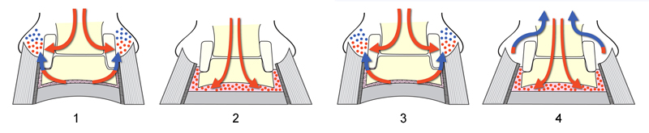

- Hoef in opgetilde stand: ………………………………………………………………………………………………………………………………………………………………………………………………………………………………………………………………………………………………………………………………………………………………………………………………………………………………………………………………………………………………………………………………………………………………………………………………………………………………………………………………………………………………………………………………………………………………
- Hoef wordt neergezet: ………………………………………………………………………………………………………………………………………………………………………………………………………………………………………………………………………………………………………………………………………………………………………………………………………………………………………………………………………………………………………………………………………………………………………………………………………………………………………………………………………………………………………………………………………………………………
- Hoef wordt weer opgetild: ………………………………………………………………………………………………………………………………………………………………………………………………………………………………………………………………………………………………………………………………………………………………………………………………………………………………………………………………………………………………………………………………………………………………………………………………………………………………………………………………………………………………………………………………………………………………
- Hoef wordt bij volgende pas weer neergezet: ………………………………………………………………………………………………………………………………………………………………………………………………………………………………………………………………………………………………………………………………………………………………………………………………………………………………………………………………………………………………………………………………………………………………………………………………………………………………………………………………………………………………………………………………………………………………

